**Book Search & Recommendation System**

|  |  |
| --- | --- |
| **Team:** | **Know-Nothings**  Todd Thompson  Chase Kent  Luke Simpson  Huy Le |

|  |  |  |  |
| --- | --- | --- | --- |
| ***Revision Number*** | ***Revision Date*** | ***Summary of Changes*** | ***Author(s)*** |
| *0.1* | *2/20/2020* | *Base UI* | *Todd Thompson* |

# **Class Diagram(s)**

**At this time, we do not have a class diagram available. It will be part of Sprint 1.**

# **ER Diagram(s)**

**This is the most basic ER diagram. We have not yet setup Firebase for our project.**

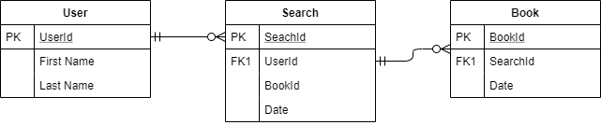

# **Information Architecture Diagram**

**If your project is web-based, you can show the structure of your website here.**

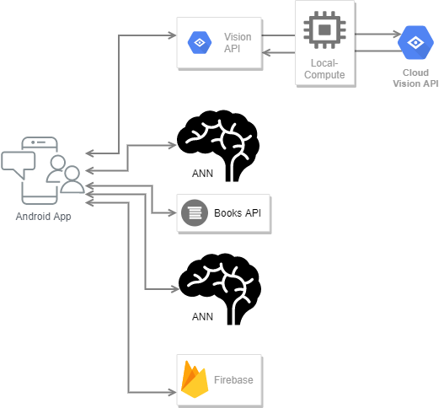

# **User Interface Wireframe(s)/Screenshot(s)**

**App Drawer Screen Main Screen**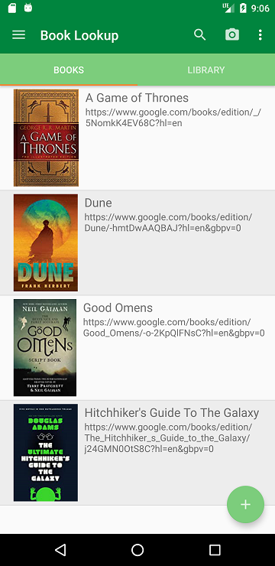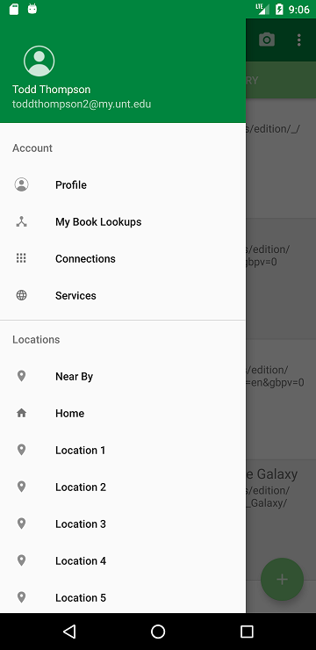

# **Design Summary**

***What if you could use your phone to take a picture of a book, and get back recommendations for other similar books, movies, songs, merchandise, gear and other items?***

***People today are more comfortable using a camera to take a photo than typing or speaking to do a search.***

***So, we present a novel approach to finding your favorite things, but in order to define a reasonable scope we will create a book search and recommendation application on Android.***

***User Steps:***

1. ***Launch Android App***
2. ***Take Photo using App***
3. ***App uses Computer Vision to remove background and focus on Book Cover***
4. ***App sends photo of Book Cover to Google Cloud Platform that has been trained using an Artificial Neural Network to identify the Book Cover and return the ISBN***
5. ***App then queries Google Books API to provide detailed info about the book and a URL to Google Books website.***
6. ***App then makes an asynchronous call to a web service which queries a Graph Database that returns all of the closest related items to the identified book.***
7. ***App displays a list of the results in a Collection of items.***

# **Design Rationale:**

We approached this project from the way Huy discussed his idea. He kept the user steps fairly straight-forward so we followed each step and brainstormed to figure out how we would approach. First, we decided on Android as the mobile platform because three out of the four members had Android devices and I was familiar with Android development from prior projects. We chose Android Studio for app development because it is the community standard and is well documented. Next, we decided that since the user would be taking a photo of the book cover, we would need to figure out how the camera and app would interpret the image as a book cover. By brainstorming, we decided that we could use some Computer Vision built into Android, or find a framework that works well with Android. As a backup, we will just force the user to fit the book cover into a rectangle shape in the camera UI. Once the user takes the photo, the image will be sent to an Artificial Neural Network on the Google Compute Cloud platform. We will train around 10 book covers for the ANN to recognize. We chose GCP because it is well documented and has a free tier for student developers. When the book cover is recognized, the ANN will return the ISBN which will be sent to Google Books API as a query. It will return detailed info about the book. We chose Google Books API after researching Amazon and Barnes & Noble as well. Amazon no longer has a free program to use their Product Search API, so we had to reject it. Next, Barnes & Noble Advanced Search is too limited for what we need. Google Books API offers the detailed info we need and is accessible. Finally, the app will send a query to our recommendation system. We have not yet decided how much of this process will be cached in the graph database or will be computed in real time. When we discussed our project openly in class, it was suggested that we use Google Firebase for the back-end. From it’s documentation, it appears that Firebase is the logical choice to support Android Apps as it is part of the same free tier for student developers. There are still a couple of moving parts where we might make changes in Sprint 1, but so far we feel confident about the basic stack of Android, GCP, and Firebase.